Topic -Compensation Benchmarking and Market Analysis
Institution: MIT School of Distance Education
Submitted by: Karleena Anthony Wilson Anita
STUDENT REGISTRATION NO.: MIT2022E02953
Duration: November 2024 – December 2024
Course: MBA – Human Resource Management
Introduction
In today’s rapidly evolving job market, companies need to remain competitive not only in their operations but also in how they attract and retain talent. Compensation benchmarking has become a strategic HR function to ensure that organizations remain appealing to high-performing professionals.
This project involved benchmarking compensation and benefits offered to HR professionals across 10 prominent companies in Mumbai. The goal was to assess the gaps in current packages and redesign a compensation structure to enhance both competitiveness and retention. This hands-on simulation helped strengthen real-time HR analytics and pay structuring capabilities.


Objectives and Importance

🎯Objectives:
- To analyze compensation packages across 10 companies for HR roles.
- To identify industry trends, median pay ranges, and key benefit offerings.
- To design a revised salary structure to align with market expectations.

🔍 Importance of the Study:
- Ensures fair pay and internal parity.
- Helps reduce attrition due to pay dissatisfaction.
- Improves employer brand perception in the job market.
- Enhances employee engagement by offering competitive perks.
By integrating this knowledge, HR leaders can create transparent, fair, and motivating reward systems.

Methodology Used
This study employed a combination of secondary data analysis and Excel-based modeling.
📚Data Collection Sources:
- Company career pages
- Salary review platforms (Glassdoor, AmbitionBox)
- LinkedIn salary insights
- Internal HR simulations

📊Excel Tools & Techniques Used:
- VLOOKUP, IF, AVERAGEIFS, RANK for data calculation
- Pivot Tables to compare pay across companies
- Conditional Formatting to flag outliers
- Charts (bar, pie, scatter) for visualization
The focus remained on mid-level HR roles, where competition for talent is highest, and pay disparity can influence decisions.

Comparative Analysis & Key Insights

After collecting and reviewing compensation data from 10 well-established companies across the Mumbai market, a comprehensive analysis was conducted focusing on three key elements: base salary, bonus/incentive structures, and employee benefits. The data revealed several patterns and strategic insights useful for designing a competitive compensation structure.
Key Findings:
- Salary Range Trends
The average base salary across all HR executive and mid-level roles ranged between ₹5.6 lakhs to ₹7.2 lakhs per annum. Leading multinational companies such as Accenture and Reliance offered salaries on the higher end, while domestic banks offered slightly lower packages but compensated with stable bonus structures and internal growth opportunities.
- Bonus & Incentive Distribution
Companies offering higher base salaries generally also included performance-linked bonuses ranging from 8% to 12%. These bonuses were often tied to quarterly or annual reviews and individual KPIs, demonstrating the increasing use of variable pay to drive performance.
- Benefits and Perks Ratings
Non-monetary compensation—such as insurance, paid leaves, hybrid work policies, and wellness programs—had a strong influence on job satisfaction and retention. Companies like Accenture and TCS scored higher on overall benefits, which included professional development courses, mental health support, and global exposure.
- Market Positioning & Competitiveness
Organizations with a well-structured total compensation package were able to attract better talent while reducing turnover. Companies that lagged in benchmarking typically had higher attrition, especially in entry and mid-level HR roles.
- Insights for Internal Strategy
By comparing these companies, it became clear that our current compensation framework needed revisions, especially in bonus distribution and benefits expansion. A structured,data-driven redesign would position our HR team more competitively in the local job market.

Insights from Market Data
From the benchmarking exercise, several patterns were identified:
- Most companies now offer hybrid work flexibility as a non-monetary benefit.
- High-paying companies also tend to have better wellness perks (e.g., Accenture).
- Many companies still lack structured performance-based bonuses for HR roles.
- Benefit rating directly influences job satisfaction and tenure.
The gap between top performers and lower-paying firms is 15–20%, indicating a strong need for realignment.

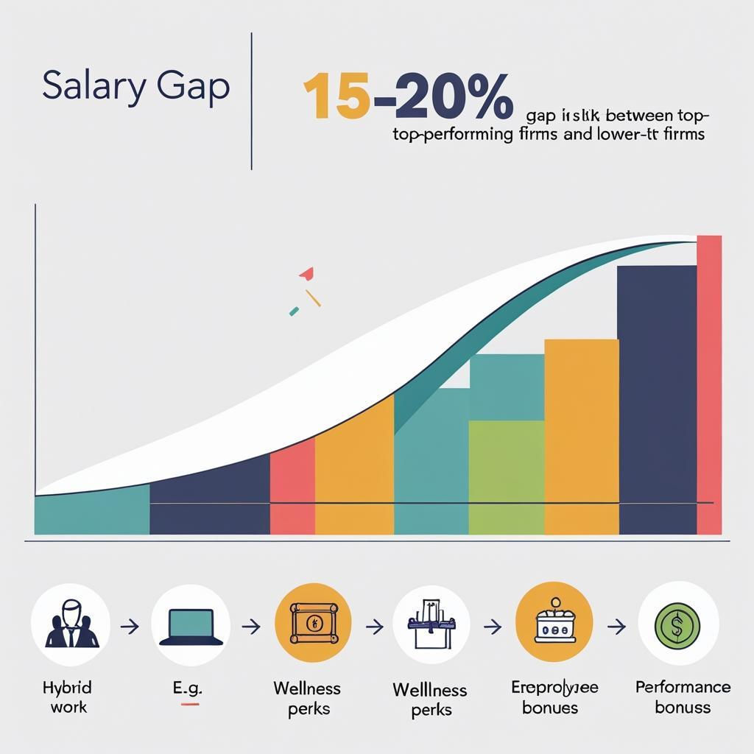

Revised Compensation Structure
Based on findings, a new compensation model was proposed for the HR department:

📌 Proposed Revisions:
- Increase mid-level HR salaries by 12%.
- Add performance-linked incentives of 8–10%.
- Introduce health & travel allowances.
- Provide employee stock options (ESOP) after 2 years.
- Allow remote work options to boost retention.
This structure improves both monetary and emotional compensation, enhancing retention while staying within budget.
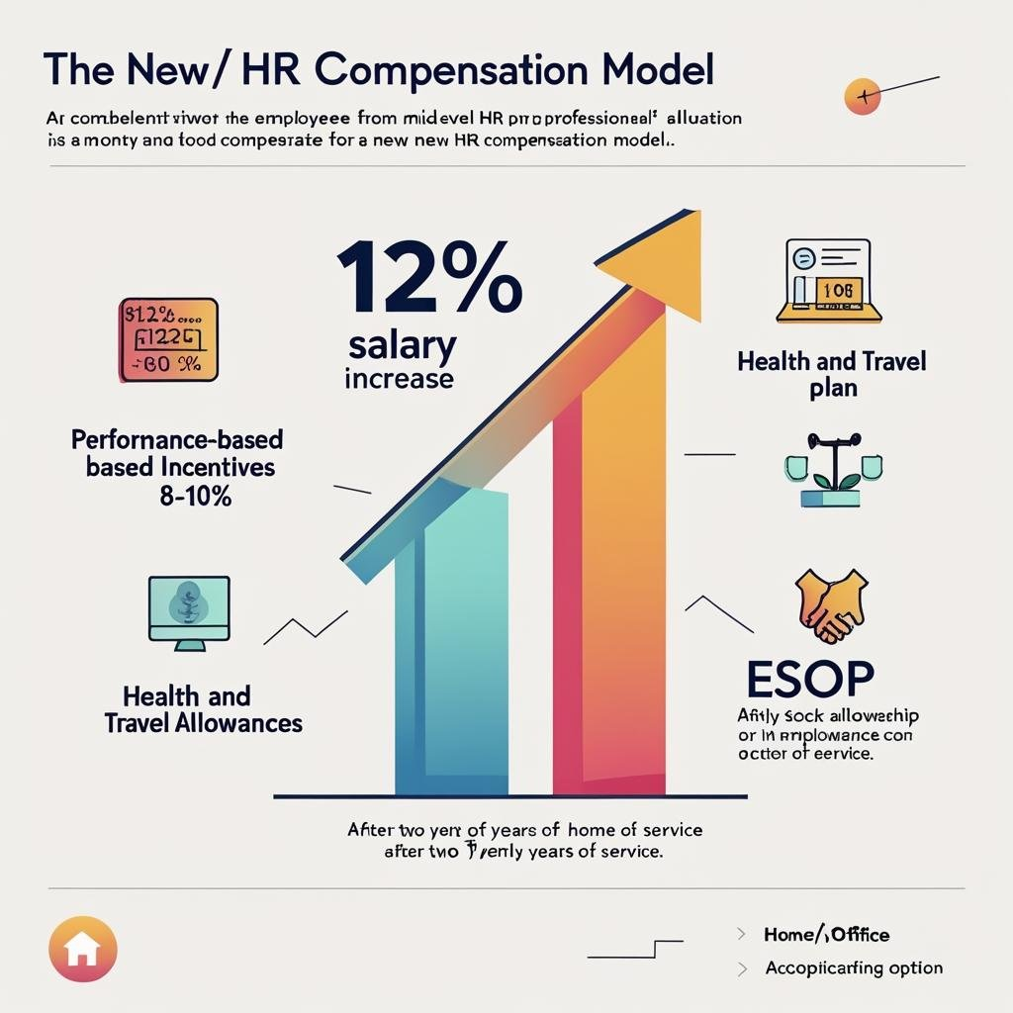

Conclusion and Visual Insights
This project reinforced the power of data-backed decision making in HR. By benchmarking compensation, we not only understand market realities but also gain the tools to influence talent strategy and business outcomes.

✅ Conclusion:
- Benchmarking ensures fair, competitive pay.
- Excel is essential for HR analytics.
- Strategic compensation planning = better employee retention.
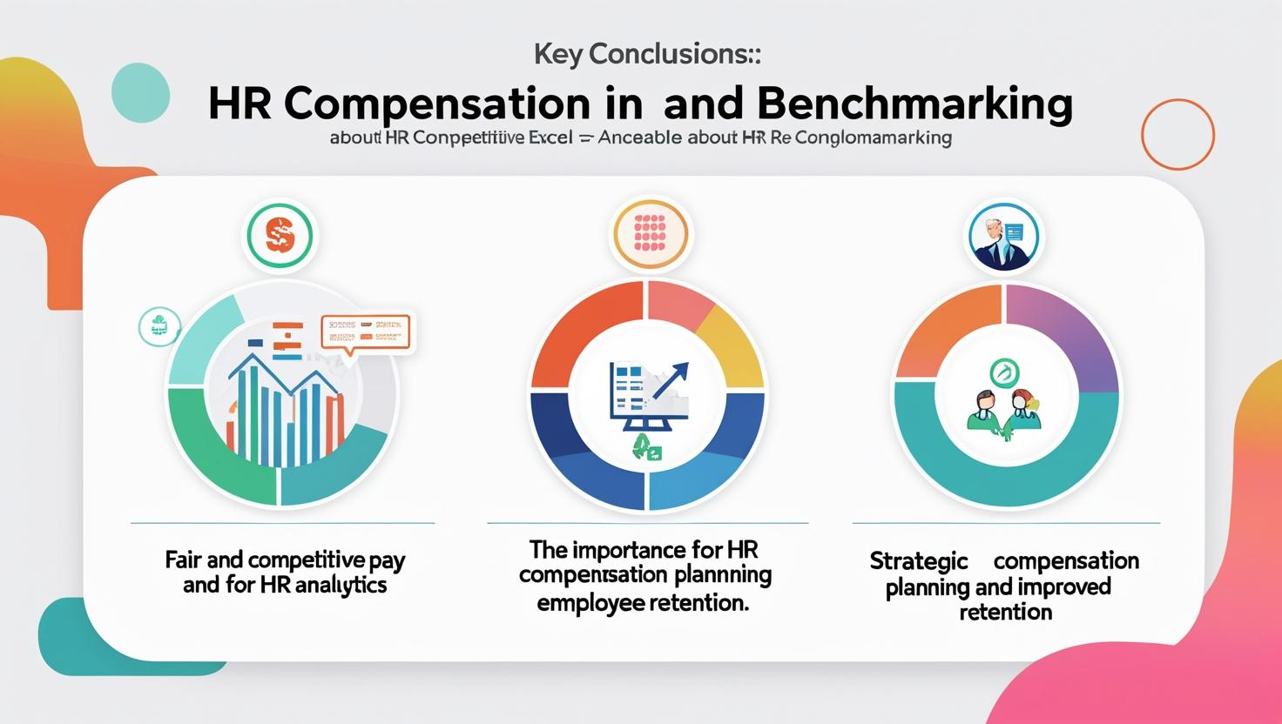

Thank You
KARLEENA ANTHONY WILSON ANITA

